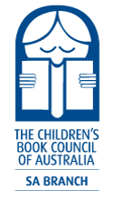
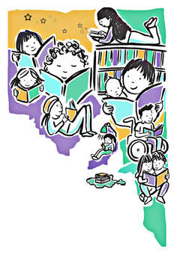
CBCA SA Branch Literature Engagement Project 2023

The Children's Book Council of Australia (South Australian Branch) is a branch of The Children's Book Council of Australia - an independent, not for profit, volunteer organization established in 1945 to promote children's literature to children, young adults (to the age of 18), parents, individuals and professionals connected with education and literature for young people.
At branch level we:
- Organise activities to provide resources and information to adults involved with children
- Stimulate wide interest and discussion of children's literature
- Encourage South Australian authors and illustrators of children's and young adult books
- Disseminate information about children's books, authors, and illustrators
- Support quality children's and school library services
- Support the appointment of judges to the CBCA Book of the Year Awards panel
- Organise professional development and community outreach functions and activities.
The Children’s Book Council of Australia South Australian Branch knows that teachers support readers in the class by teaching students how to read, by being a reading role model and contributing to a whole school culture where reading for pleasure is encouraged and supported. The purpose of the CBCA SA Branch Literature Engagement Project 2023 is to motivate young people to read for pleasure and develop a love of reading.

CBCA SA Branch Literature Engagement Project 2023 will provide financial support and professional development opportunities for two schools (situated 200kms+ from the Adelaide CBD).

CBCA SA Branch responsibilities:
- Provide Corporate 1 Membership - $65.00 for 2023
- Provide new children’s books to the value of $200
- Provide a choice of relevant professional learning opportunities
- Provide support for adults acting as facilitators of the CBCA Sun Project Shadow Judging (https://shadowjudging.cbca.org.au/).

Successful applicant responsibilities:
- Ensure at least one staff member attended a minimum of one online/face to face event.
- Provide a short interim update in July 2023 and a brief article (250 words), for the CBCA SA Branch November newsletter, reporting on the benefit to the school of engagement with the Literature Engagement Project 2023.
- Register for, and complete, the CBCA Sun Project Shadow Judging 2023.

